
10/15/2024
Evaluation Report
E-Commerce Data
UK-Based Online Retailer
Submitted By:
Elijah Shepherd

Submitted To:
Manager
Introduction
Note that in the python notebook, the relevant analysis for this project is in the Analysis IV section, which starts at about two-thirds of the way into the python notebook. The previous sections, Analyses I-III, explore returns, profits earned over various periods of time, & order sizes placed by customers in different countries.
Background: You are working for an online retailer. Currently, the retailer sells over 4,000 unique products. To take inventory of the items, your manager has asked you whether you can group the products into a small number of categories. The categories should be similar in terms of price and quantity sold and any other characteristics you can extract from the data.
Purpose: Objectives of the analysis included:
- Make note of strange values in the dataset that can influence the evaluation of the analysis. Clarify how to deal with these strange values.
- Determine a course of action (or multiple) to categorize the products in the dataset & evaluate their effectiveness.
- Perform analyses using various parameters in the dataset.
- Provide ideas for further analysis.
The findings & relevant analyses are to be provided to the appropriate manager so that they can be utilized to help determine a course of action & basis for categorizing the products that the retailer possesses.
The Data: The dataset used in the project contains orders & transactions made by customers in different countries from December 2010 to December 2011. The orders pertain to a UK-based company & online retailer that mainly sells unique all-occasion gifts. Many of its customers are wholesalers. Each row consists of a transaction (or invoice). There are eight main parameters for each transaction including the invoice number, the stock code of the relevant product, a description of the product, the quantity ordered, the date of the invoice, the price of one unit of the product (in pounds), a customer identifier, & the country in which the customer resides.
The original dataset (defined as the "orig_data" variable) had about 542,000 data points, one for each unique transaction within an invoice. Some invoices only contained a purchase of one item whereas others contained purchases of multiple distinct items. This original dataset had a size of 33.1+ megabytes (MB). Two of the eight columns contained null (missing) values: the product 'Description' column had about 1,500, & the 'CustomerID' column had about 135,000. These missing values aren't immediately replaceable because there is not necessarily a clear way to determine what they should be imputed with. Replacing the missing 'CustomerID' values would involve guesswork at best because there isn't any tool provided in the dataset that can be used to verify what these values should be for each transaction. For the missing 'Description' values, an appropriate solution would be to look up the associated 'StockCode' value & determine what other product 'Description's are associated with this value; however, for many 'StockCode' values, they pertained to multiple product 'Description's, thus making replacing these missing values considerably more challenging. Ultimately, these null values were not imputed nor dropped from the dataset, but they didn't have any influence on the analyses in this project.
There were 5,268 data points which had duplicate instances. They total 10,147 rows. 4,566 data points only had one duplicate, but others had multiple. In removing duplicates across all columns from the dataset, it decreased the size of the dataset from 541,909 to 536,641 rows (36.8+ MB). The cleaned version of the dataset was labelled as the variable "data."
There are quite a few intricacies in the data that are important to know before proceeding. Regarding the 'InvoiceNo' parameter, which assigns a unique six-digit number to each transaction, if it begins with a "C," it indicates a cancellation. There were about 9,300 such data points in the dataset. Regarding the 'Country' parameter, there are a few values that are not immediately clear such as "Unspecified," "EIRE," & "RSA." There wasn't any additional information provided regarding these values in the dataset (nor the source), but it is most probable that these latter two values stand for Ireland & the Republic of South Africa respectively. Furthermore, the 'Quantity' column, which indicates the number of items that were purchased, sometimes contains negative numbers. These instances indicate that a return took place.
The 'Description' column is the most relevant & quirky parameter in the dataset & this project. Although the dataset claims that this column specifies the name of the product, this is not the case in every instance. There are several data points in which the 'Description' value does not describe a specific product, but rather provides some sort of brief label or statement. Some examples include "Missing," "Adjustment," "Water damaged," "taig adjust no stock," etc. It was theorized that these values most likely pertain to the nature of the corresponding transaction such as a reason for a cancellation or return. Given the size of the dataset, these 'Description' values can be problematic & difficult to find. Fortunately, the dataset incorporated (intentionally or not) an indicator to help differentiate between 'Description' values that actually pertain to a product & those that do not. In most cases, 'Description's of actual products were formatted entirely (or mostly) in uppercase letters whereas non-products were often formatted in lowercase or mostly lowercase letters. This characteristic was helpful in being able to filter out undesirable 'Description's & their corresponding data points as well as finding actual product 'Description's that were not formatted completely in uppercase letters. Unfortunately, it wasn't fully capable of finding every non-product 'Description' value, but any leftover values did not have any consequential influence on the relevant analyses.
An excerpt of the dataset is provided below.
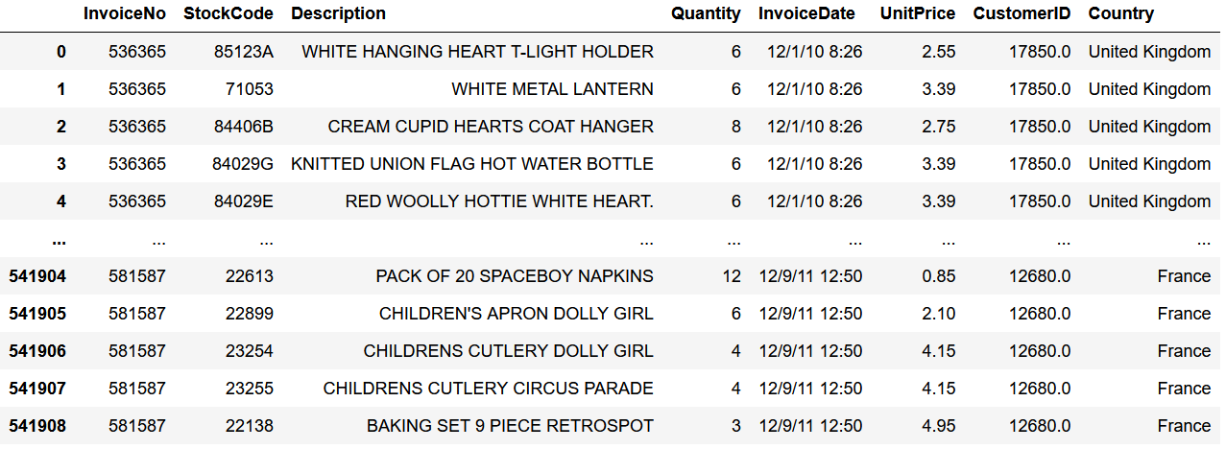
Analysis
The Analysis: The analysis in the project that is relevant to this report is in the Analysis IV section, which begins about two-thirds of the way into the python notebook. There are multiple datasets & variables that are relevant, each of which will be mentioned throughout this report.
With the dataset provided, the best way to differentiate between unique products is by using the 'StockCode' & 'Description' parameters; however, as mentioned previously, there are some 'Description' values that do not describe a specific product. Additionally, some 'StockCode's correspond to multiple 'Description' values & vice versa. Other parameters that could be of use for this analysis include 'StockCode,' 'Description,' 'Quantity,' & 'UnitPrice.' 'InvoiceDate,' 'CustomerID,' & 'Country' are more related to the order & customer rather than the product, but they could be explored in future analyses. By comparing how similar data points are in their values across the 'Description,' 'Quantity,' & 'UnitPrice' columns, it could be useful in determining how to categorize the different products.
For this dataset, with half a million data points & more than 4,000 unique products, it is neither realistic nor efficient to go through each of them by hand & determine an optimal category for them all. Fortunately, the manager has requested that the products be grouped into "a small number of categories." The less categories there are, the more generic they will have to be if they are to encompass over 4,000 unique products. Furthermore, categories have to be made that appropriately differentiate the many products. Without a knowledgeable understanding of what products this dataset contains, it is difficult to determine what these categories should be named or what products they refer to. As such, it would be beneficial to peruse over the products in the dataset in order to brainstorm some categories that best fit & encompass the many products.
With around 530,000 data points in the dataset, it is highly likely that a significant number of the ~4,000 products have a diverse range of values across all of the parameters. With so many data points, it can make categorizing these products difficult. Instead of trying to classify these products based on several parameters, a simpler solution, or at least part of a solution, could be to analyze the dataset via a couple of parameters at a time. The analyses in this project specifically explored the 'Quantity,' 'UnitPrice,' & 'Description' parameters.
In regard to the 'Quantity' & 'UnitPrice' parameters, which have numerical data, they were used to categorize the products by splitting their values into quantiles. For each 'Description,' the most popular 'Quantity' & 'UnitPrice' values were obtained which were then used to classify the products into different categories based on which 'Quantity' &/or 'UnitPrice' quantile they fell within. The number of quantiles was based on what an ideal & appropriate number of categories would be for classifying the 4,000-plus products. Initially, this number was considered to be somewhere between 10-30 categories.
The 'Description' parameter contains strings of text including letters, numbers, & other characters, & therefore, different approaches had to be used than those used for the 'Quantity' & 'UnitPrice' variables. With so many unique values, a more ideal & realistic approach would involve using some sort of natural language processing (NLP) technique or machine learning application that could evaluate the 'Description's values, assess the diversity of the physical items in these values, & conceive some categories that could logically encompass them. Unfortunately, my limited understanding & experience with such techniques makes implementing them challenging & likely ineffective. Of course, they could be researched online, but such time is not always available, & so I decided to find other suitable approaches, even though they are probably more time consuming, tedious, & less realistic.
Such approaches involved sifting through the many 'Description' values to find individual words or terms within them in order to determine the actual physical item that the product 'Description' alluded to. With these items, they could be used to brainstorm potential categories that best encompass & differentiate the 4,000-plus distinct 'Description's. With these categories, the products could be classified & put into that which is the best fit. Obviously, without the help of some natural language processing technique or machine learning application, this would be an extremely lengthy & tedious process, & it would be easy for a human to make a mistake or inconsistently categorize the many products.
Furthermore, the concept of string matching was used to quantify relationships between 'Description' values. By comparing different product descriptions linguistically, a similarity score can be calculated where a higher value implies that the two strings are more similar. Of course, this doesn't necessarily imply that pairs of 'Description's with high similarity scores will pertain to the same product. This aspect of string matching doesn't make it the most suitable tool for the purposes of this analysis because a high similarity score typically results from the pieces of text having common words or phrases. Nonetheless, it can still produce valuable results. By searching for pairs of 'Description's that have large similarity scores & reviewing them to check if they pertain to the same product or not, it can become easier to determine whether they belong in the same category.
The specific method used in this section is called "fuzzy" (or "approximate") string matching, which relates two strings based on their linguistic patterns.
Before proceeding, some potential categories were hypothesized & brainstormed to keep in mind as different 'Description' values were presented & analyzed throughout the project. These categories are listed below. With more time & resources, subsets of these categories can also be constructed. Ideally, these would be based off of other inherent details pertaining to the products such as size, color, price ('UnitPrice'), what season they pertain to if any, etc.
- Accessories, Appliances, Arts & Crafts, Clothing, Decorative, Fashion, Furniture, Games, Gifts, Handheld, Holiday, Kitchen, Living Space/Homey, Office Supplies, Personal, Storage, Tech/Electronics, Toys, Vouchers, Non-products, Other, etc.
Multiple python modules were used in the project including matplotlib, seaborn, random, fuzzywuzzy, regex (re), & others. Additional details & discussions are included throughout the project.
Results
Make note of strange values in the dataset that can influence the evaluation of the analysis. Clarify how to deal with these strange values.
As discussed previously, there are several 'Description' values that seem to refer to something that is not a physical item (e.g., "Adjust bad debt," "Bank charges," "Discount," "Manual," etc.). These values are not directly relevant to this project & so they can be disregarded, but it would be ideal to filter them out beforehand or know what they are so that they can be put into their own category. Recall that a tool to help differentiate between most non-product 'Description's & actual 'Description's was whether they were mostly in uppercase or lowercase letters. Given these inconsistencies in the 'Description' parameter, the best way of finding actual products was to search for values which were formatted entirely in uppercase letters. Then, the remaining 'Description's which do not fit this description, which constituted about 201 unique values, were sifted through to find any other values that actually described a specific product.
There were 27 'Description's that weren't entirely in uppercase that did actually specify an actual product. These were added to the data of interest, which was defined as the variable "actual_products_data." The corresponding product 'Description's were compiled into the list "actual_products_descs," which contained 4,035 distinct elements.

Determine a course of action (or multiple) to categorize the products in the dataset & evaluate their effectiveness.
Given the size & variety of the dataset, it was helpful to first approach the analysis in smaller increments rather than try & incorporate as much as possible. In other words, instead of attempting to include every parameter in the dataset to categorize the products, a more useful approach involved evaluating one or a few parameters separately. Then, the results were methodically joined together where it was applicable. Of course, a more ideal & realistic approach would involve using some sort of natural language processing technique or machine learning application that could evaluate the 'Description's values, assess the diversity of the physical items in these values, & conceive some categories that could logically encompass them. Unfortunately, a lack of experience, knowledge, & confidence in this subject restricted the analysis of this project to more elementary methods, including quantifying the products based on their values across the 'Quantity' & 'UnitPrice' columns, compiling a word count of words & phrases across the product descriptions, & string matching. The latter two approaches used the 'Description' parameter.
The first parameters that were analyzed to help evaluate how to categorize the products in the dataset were 'Quantity' & 'UnitPrice.' These were the most appropriate numerical parameters to use because they were easily manipulable & easier to traverse than others, such as the 'InvoiceDate' column. After evaluating the distributions of these parameters to help build a more solid understanding of them, the idea to split these parameters using quantiles came to mind as an effective method in classifying the few thousand distinct products. Quantiles can split a range of numerical values based on where they are in a distribution. Their ability to split such data in a representative fashion is useful when dealing with the values seen in the 'Quantity' & 'UnitPrice' parameters, which span wide margins & do not have a normal, bell-curve-like distribution.
These quantiles can help in categorizing the 4,000-odd unique products. For each 'Description,' the most popular corresponding 'Quantity' & 'UnitPrice' values were obtained. Based on what quantiles these values were in would then dictate the category in which the associated product would fall within. Recall that the manager requested that the 4,000-plus products be grouped into a small number of categories. Though vague, an ideal number of categories that could classify this number of products may be anywhere between 10-30. This range guided how many quantiles were used in splitting the 'Quantity' & 'UnitPrice' values. Initially, 50 categories were trialed, which corresponded to five & ten quantiles for 'Quantity' & 'UnitPrice' respectively.
For each distinct 'Description,' the number of instances per 'Quantity'-'UnitPrice' quantile pair were totaled to determine which was the most common. The five most common quantile pairs were ranked for each 'Description' based on the number of instances there were. Of course, some 'Description's did not have enough data points to associate with five unique 'Quantity'-'UnitPrice' quantile pairs, but ultimately, the products would be categorized based on their most common quantile pair. The five most popular categories were included just to add some additional information. For example, some product 'Description's may have had an equal number of data points in multiple quantile pairs, thus implying that they could possibly be put into more than one quantile-pair category. For such cases, it would have to be decided whether to put them into multiple categories or just one, including an explanation as to why & how this was solved.
Furthermore, the range of values for both the 'Quantity' & 'UnitPrice' parameters were listed to provide further information regarding the category that each 'Description' fell within.
Contrary to the analysis of the 'Quantity' & 'UnitPrice' parameters, which contained numerical values, the 'Description' parameter contains strings & objects that describe product names. As such, a different approach was taken in the analysis of it regarding how the 'Description' parameter could be used to categorize the products in the dataset.
When dealing with text values, a more efficient approach would be to utilize natural language processing techniques, such as text classification, named entity recognition (tagging), parts-of-speech tagging, or information retrieval to name a few. Unfortunately, I am not proficient enough in such areas of analysis to properly utilize them here in this project, leaving more basic & time-consuming techniques as better options. With more than 530,000 data points & 4,000-plus unique products, such techniques that do not utilize machine learning & similar applications are likely to be unrealistically time consuming. Even if useful solutions are found, which in this case concerns categorizing these products, they aren't likely to be as representative & accurate as what a more efficient process may end up with.
A good & relevant example that was found online is linked here. This example, which is described well & in an organized manner, contains concepts & techniques that would be useful for analyses of the 'Description' parameter in regard to this section, but a considerable portion of the steps go over my head. It would not be appropriate for me to simply copy & paste the work from this link into my notebook & attempt to apply it when I do not understand most of the concepts & functions which are being used. Moreover, it would be easy for me, with my lack of knowledge regarding Natural Language Processing techniques, to make a mistake when importing &/or adapting such code for my purposes.
Nevertheless, one idea that was used regarding the 'Description' variable was to get a head count of each individual word across all of the 'Description' values in the dataset. In doing so, this revealed which words were most popular among the 4,000-odd unique products. With these popular words, it could provide some guidance as to how categories could be named & formed. It should be noted that the code searches for individual words by splitting each 'Description' value by whitespaces (" "); however, this may not always equate to complete words & instead should be described as finding each group of characters. For example, the 'Description' "FOLK ART GREETING CARD,pack/12" would be split into four different "words," though the last one--"CARD,pack/12"--can hardly be referred to as one word. There are several other 'Description's that contain other random delimiters & characters including commas, slashes, hyphens, & more.
Furthermore, most words in these product 'Description's do not specify an actual product but instead are adjectives, prepositions, or other non-nouns. For example, of the product "WHITE HANGING HEART T-LIGHT HOLDER," the actual item is the T-light holder, whereas the first three words serve to describe the product. Words like these do not necessarily help when trying to determine how to categorize the 4,000 unique products in the dataset. If anything, they would be useful in creating subcategories, like what color is an item.
Ideally, in finding the most popular words across the unique products, it would provide guidance as to what the majority of items are in the dataset which would then help provide more insight as to what the different categories could be. After categories are created, it would require going through each unique 'Description' & determining the most appropriate category for which each product would fit. Obviously, without the help of some natural language processing (or other) technique, this would be an extremely lengthy & tedious process, & it would be easy for a human to make a mistake or inconsistently categorize the many products.
As discussed previously, there are values in the 'Description' column that do not describe or include a specific product/item. Once again, these values are not necessarily relevant to this analysis (e.g., "wrongly sold sets"); however, they could simply be grouped into their own category which contains "products" & their data points which do not describe a specific product. Given these inconsistencies in the 'Description' parameter, the best way of finding actual products was to search for values which were formatted entirely in uppercase letters. Then, the remaining 'Description's that do not fit this description, which constitutes about 201 unique values, can be sifted through to find any other values that may actually describe a specific product.
In this dictionary containing word counts, many of them did not indicate a specific product, but instead, they were adjectives (e.g., colors, "Christmas," "Small," "London"). Though valuable, these words don't provide great insight as to the different kinds of physical products that are sold by the company. As such, it would be more useful to evaluate these words counts without these non-product words. However, this would require going through the data, identifying words that allude to a physical item, & removing those that do not--a tedious, subjective, & time-consuming process.
With this information, the next step in this process would involve identifying the most popular words that represent physical items, creating between 10-25 categories that encompass these items, then group the 4,000-odd unique products into these categories. Once again, this is not realistic to do by hand & would be more doable using some machine learning program or NLP technique, but my limited knowledge on such subjects restricts this specific analysis from proceeding much further.
After this word-count experiment, the distinct 'Description' values were evaluated by calculating similarity scores between them. Pieces of text describing different products that are more similar could indicate that they describe similar items, suggesting that they could be grouped into a category together. Those that are less similar may imply that they do not share similar items & that they should not be put into the same category; however, this process doesn't directly relate products that are different in name but similar in function. For example, a towel & a mop share very few common features linguistically, but they share some similar purposes in that they can be used for cleaning purposes. Additionally, some 'Description's may be similar linguistically but their products may not have any functional commonalities (e.g., a red sock & a red laptop).
For the purposes of this analysis, such a process of measuring the linguistic similarities of strings can provide some value, but there are many potential pitfalls that can indirectly lead to inaccurate & irrelevant conclusions. Nonetheless, this part of the analysis aimed to group products together based on their similarity scores as calculated by comparing two 'Description' values linguistically. Since this parameter only contains strings of texts (including various characters & numbers), a quantitative way to evaluate these values could involve measuring how similar they are. Though there are many techniques that can be used to measure similarity between excerpts of text, one that was used in this analysis is the concept of fuzzy string matching. As Nibedita Dutta puts it,
"Fuzzy string matching, also known as fuzzy matching, is the technique of finding strings that match with a given string partially and not exactly. When a user misspells a word or enters a word partially, fuzzy string matching helps in finding the right word – as we see in search engines. The algorithm behind fuzzy string matching does not simply look at the equivalency of two strings but rather quantifies how close two strings are to one another. This is usually done using a distance metric known as 'edit distance.' This determines the closeness of two strings by identifying the minimum alterations needed to be done to convert one string into another. There are different types of edit distances that can be used like Levenshtein distance, Hamming distance, Jaro distance, etc" (Analytics Vidhya).
The article of relevance goes on to describe multiple techniques, metrics, & examples that provide more details as to how fuzzy string matching is done. For this analysis, the "process" module was used, which takes a piece of text as input & measures the k-most similar pieces of text in some list along with a similarity score that ranges from zero to 100. By default, k is five. Regarding this dataset, using this module would involve taking each of the 4,000-odd unique 'Description' values, & measuring its similarity to each of the other 'Description' values. Obviously, this would amount to an enormous number of computations such that this process may take an indescribably long time. As such, a good alternative was to sample a portion of the 4,000 distinct 'Description' values, which in this case was 500 values. For each 'Description,' the five most similar 'Description's were. These products & their similarity scores were then put into a data frame where each row corresponded to a distinct 'Description.' Ten more columns were also appended that contain each of the five-most similar 'Description' values & their similarity scores.
This data could be used to determine what products are similar & how similar they are to each other, thus providing some guidance as to what potential categories could be made & how many. Of course, this method would still require considerable levels of meticulous, by-hand analysis in the process of categorizing the 4,000-plus products (or even just the 500 products used in the project), but if a metric is available that helps in this process, it would definitely aid in how tedious & time consuming it may be.
Once these similarity scores were obtained, they were analyzed to get a better understanding of what the numerical values indicate. In other words, if two 'Description's had a similarity score of 86, how similar qualitatively are these two pieces of text? Is this value this high because they are referring to the same product, or is it because they contain similar words, letters, characters, numbers, or whatever else? A high similarity score doesn't necessarily imply that the two 'Description's refer to the same product. These instances could contain similar adjectives & other terms while still pertaining to various products. Such analysis could provide some guidance as to how this data could be used to categorize the products in the dataset.
Following such analyses, it became evident that most pairs of product 'Description's with high similarity scores did have some clear difference between them which usually pertained to some descriptive identifier, such as the color, size, or some key feature regarding the products' design/appearance. As the score decreased, the less commonalities a pair of 'Description's contained & the less likely it became that they referred to the same physical item. With the data that was sampled & put through this experiment, the most similar pairs of products were taken & were grouped into hypothetical categories to provide a basic example of how this analysis could be utilized to accomplish the goals laid out by the manager. Ultimately, however, the size of the dataset & number of unique product 'Description's made completing this approach unrealistic.

Perform analyses using various parameters in the dataset.
Quantity, UnitPrice Parameters
Firstly, the 'Quantity' & 'UnitPrice' parameters were evaluated & used to categorize the 4,000-plus distinct products in the dataset. The values across these parameters were split into quantiles which were paired together across the two parameters to create pairs of quantiles. These pairs would be the categories in which the products would be classified into. Initially, the 'Quantity' & 'UnitPrice' parameters were split into five & ten quantiles respectively, which totaled 50 distinct quantile-pair categories; however, this number was considered to be too large & was reduced to 20—four & five quantiles for 'Quantity' & 'UnitPrice' respectively.
For each data point, the corresponding 'Quantity' & 'UnitPrice' quantiles were inputted into two new columns. An example of this resulting dataset, defined as the variable "UP_Quan_quantiles_data," is shown below.
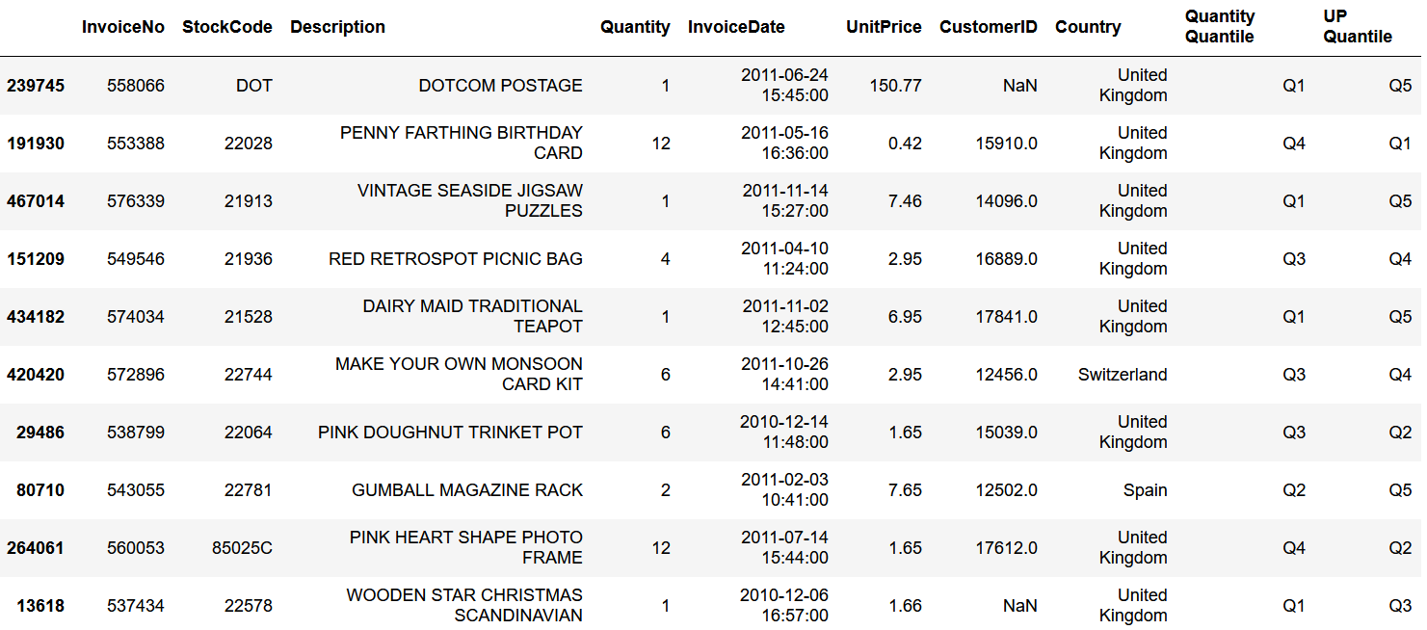
With these two new columns, 'Quantity Quantile' & 'UP Quantile,' the number of data points across each of the 20 'Quantity'-'UnitPrice' quantile pairs were totaled. Each accounted for somewhere between about 3,800-55,000 data points. In terms of unique product 'Description's, these quantile pairs accounted for anywhere between about 430-1600 values. For each 'Description' & quantile pair, the total number of data points were totaled. Some of these data, contained in the "num_descs_per_Q_UP_quan" variable, are shown below.
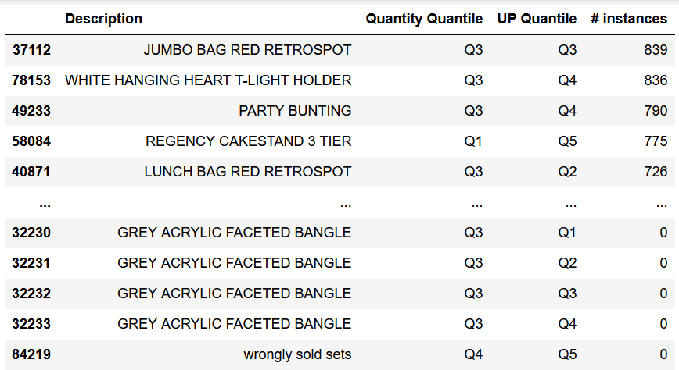
Additionally, the variable "desc_per_quantiles" contains the number of data points for each 'Description' & each 'Quantity' & 'UnitPrice' quantile, though this data is not incredibly legible. An example is shown below. Note that there are 4,211 unique product 'Description's in this data, but there are several values which do not specify actual products (e.g., "wrongly sold as sets"). If the values of each 'Description' were summed row-wise (horizontally), it would total the number of data points per 'Description.' If the values were summed column-wise (vertically), they would total the number of data points per 'Quantity'-'UnitPrice' quantile pair.
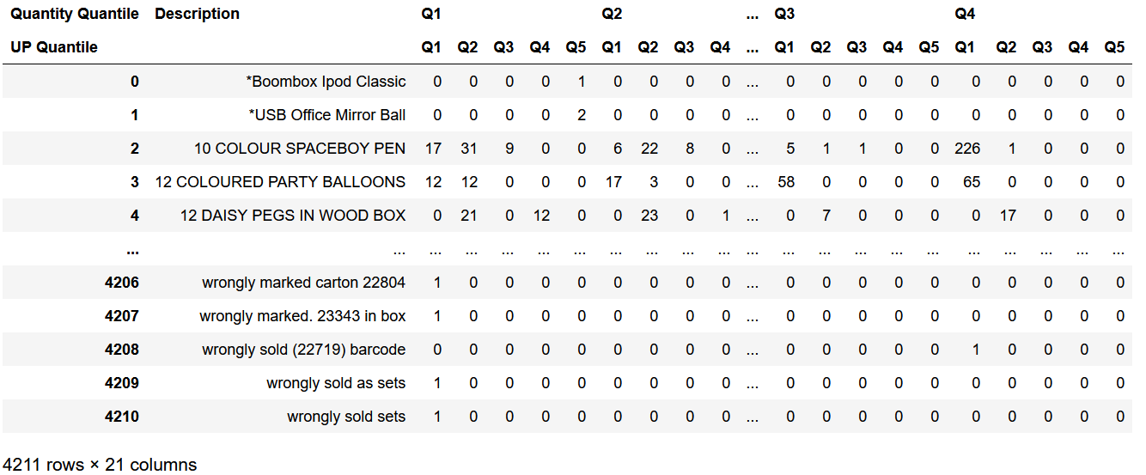
For each 'Description,' the five most popular quantile pairs were obtained & ranked based on the number of data points that fell within each quantile pair. This data is contained in the "desc_top5_quans" variable, a sample of which is shown below.
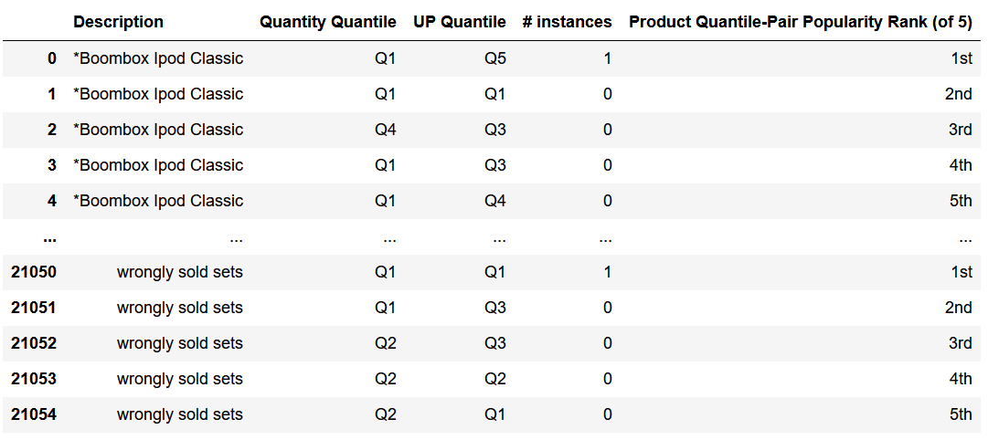
Note that there are multiple product 'Description's for which there are zero or an equivalent number of data points across multiple quantile pairs which may not be reflected in the column indicating the ranking, as seen in the snapshot below. Ultimately, only the most popular quantile pair dictated which quantile "category" a 'Description' fell within, but if two different quantile pairs each account for the most data points, it incurs the question of which category (quantile pair) should the product be put into. Although this wasn't ultimately settled in the project, there are realistically only two methods which are viable. Such products can be put into each of these corresponding quantile-pair categories, or they can be put into one of them. For this specific analysis regarding only the 'Quantity' & 'UnitPrice' parameters, it may be more appropriate for such products to be put into both categories because there is no other information that can be used to help decide which category may be more optimal. On the other hand, if more details from the dataset were obtained to help provide more contextual information regarding these data points, it may be more appropriate for such products to be put into only one of the categories. As an example, the 'Description' value can be used. If the product 'Description' of such a product relates more to other 'Description' values found in one quantile-pair category than the other, this could be a deciding factor as to what category is more appropriate for such products.
Some additional information was obtained & compiled into the variable "num_prod_per_categ_20" which describes each 'Quantity'-'UnitPrice' quantile pair a bit more thoroughly. For each of the 20 categories, the number of unique product 'Description's are included as well as the range of values corresponding to each 'Quantity' & 'UnitPrice' quantile span. A snippet of this data is shown below. Note that this dataset only includes product 'Description's based on their most popular quantile pair, & so the '# Unique Products' column sums to 4,211 total items. In the last two columns, brackets indicate that the value is included whereas parentheses indicate the opposite.
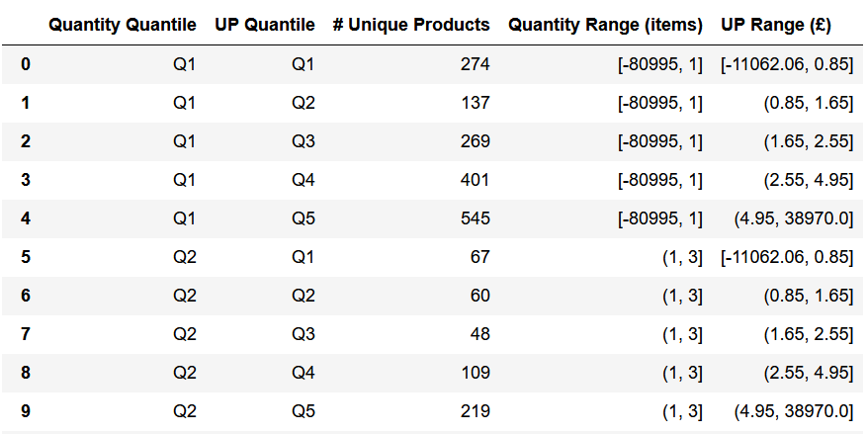
When referring to these quantile-pair categories, more descriptive names could be used which would be helpful to anyone unfamiliar with this data. For example, the category concerning products that fall within the quantiles Q1 for 'Quantity' & Q2 for 'UnitPrice' could be named something like "Lowest Quantity Quantile, 2nd Lowest UnitPrice Quantile" to give the reader more context.
Furthermore, the product 'Description's within each of these 20 categories could be evaluated to see what similarities & differences there are between all of the products. With such analyses, subcategories could be constructed within each main category; however, given the size of some of these categories (the largest accounts for 694 unique products), this is not necessarily realistic without using some natural language processing method that could relate similar &/or similarly named products.
To access the five most popular quantile-pair categories of some product, use the following code:
To get the most popular category for some product--the category in which the 'Quantity' & 'UnitPrice' of some product most often falls within--add a second condition, as shown below:
One example of the final results of the analyses of these two parameters is shown in the image below. The product "10 COLOUR SPACEBOY PEN" clearly belongs in the quantile-pair category that represents products with the largest 'Quantity' values & the lowest 'UnitPrice' values. In other words, most people who ordered this product preferred to purchase them in bulk & when these items were at their cheapest.

Description Parameter
After the 'Quantity' & 'UnitPrice' parameters were evaluated, the 'Description' variable was assessed. Given the nature of these parameters, the latter could not be analyzed in the same way as the former two were. As such, other techniques were used including totaling word counts & calculating similarity scores across all of the distinct 'Description' values.
As mentioned previously, there are some intricacies regarding the 'Description' parameter. Firstly, not all product 'Description's specifically describe an actual product. There is a formatting trick evident in this variable which mostly differentiates between 'Description's of actual products & those that are not, but this was not the case universally. Moreover, in each 'Description' value, there are usually multiple words (or group of characters), but most of them serve to describe the actual item which only makes it more challenging to determine what the actual item is. Without using some machine learning program or natural language processing technique, the size of the dataset & large quantity of distinct 'Description' values makes evaluating these products all the more difficult. Nonetheless, a couple of methods were utilized in the analysis of this parameter.

Description – Word Counts
Firstly, a word count of all words (groups of characters) across each of the 4,000-plus unique 'Description' values was constructed to get an idea of what the most common items were in the dataset. Ideally, this would help provide a basis & some guidance as to what categories could be made to encompass the few thousand products.
Beforehand, the 'Description' parameter was reviewed to try & weed out any non-product values & select those that did describe an actual product. This was done by manipulating the formatting trick & sifting through the mostly-lowercase-text values to find any other values that needed to be included in the analysis. Of the 201 distinct values that weren't completely in uppercase text, 27 of them did refer to a specific product, & so these values were included in the relevant data for this analysis (reference the variable "actual_products_data"). In total, there were 4,035 unique 'Description' values that referred to an actual product, which can be obtained via the "actual_products_descs" variable in the project.
With the main product 'Description's of interest obtained, the data was manipulated to total a word count for each group of characters across all of the 'Description' values to determine what products are most common in the dataset. An example of some of the code is shown below which calculated the number of times each word was found per 'Description.'
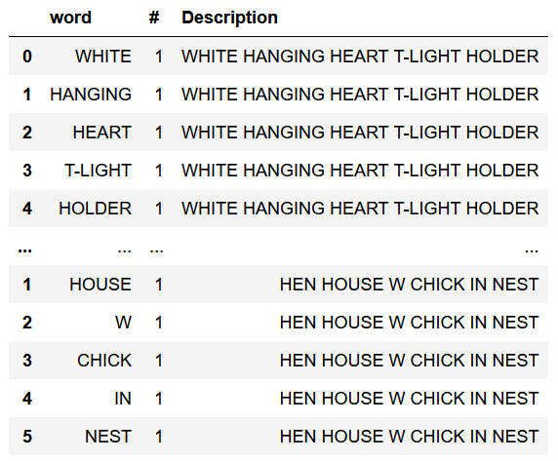
To get a sense of the distribution of these word counts, a couple of plots were made that helped provide some visual aid.
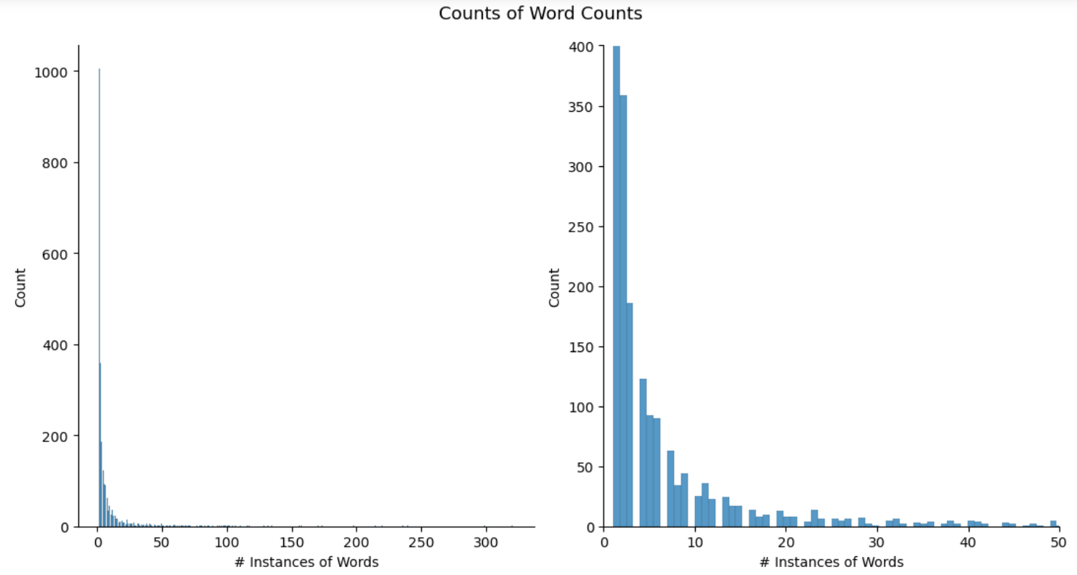
The figure above displays the distribution of word counts contained across the 4,000-odd distinct 'Description' values. The first (left-hand side) plot displays all of the data whereas the second (right-hand side) only shows a snapshot of this larger figure. Specifically, this second figure only shows words that showed up 50 times or less among all of the unique product 'Description's.
The distribution of this data is quite reminiscent of a normal distribution, as illustrated by the well-known "bell curve." For most words, they only occur once or a couple of times. As the word count increases, there are significantly less words. Beyond a word count of about 20, the nature of this data changes to a more inconsistent, oscillatory behavior all the way up until a word count of approximately 100-120.
The most popular word, "SET," occurs 321 times across the 4,000-plus unique 'Description' values. Conversely, there are 1,005 distinct words (or phrases, numbers, strings of text, etc.) that only occur once.
Another plot was made to illustrate the most popular words that were found across the many product 'Description's.
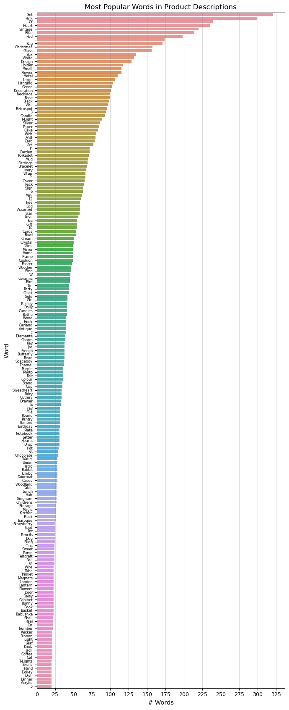
The figure above illustrates the number of times each word (or set of characters) shows up across the 4,000-odd unique 'Description' values in the dataset. The term "Set" is the most popular word as it is present in about 320 unique product 'Description's. The words present in this plot, which account for 187 of 2,370 total "words" found across all 'Description' values, all associate with at least 20 distinct 'Description's.
There are a lot of words (or sets of characters) that do not indicate a specific product, but instead, they exemplify adjectives (e.g., colors, "Christmas," "Small," "London"); the eighth most popular "word" is a black space—" ". Though valuable, these words don't provide great insight as to the different kinds of physical products that are sold by the company. As such, it would be helpful to see this plot without these words. Of course, this would require going through the data, identifying words that allude to a physical item, & removing those that do not—a tedious, subjective, & time-consuming process.
With this information, the next step in this process would involve identifying the most popular words that represent physical items, creating between 10-25 categories that encompass these items, then group the 4,000-odd unique products into these categories. Once again, this is not realistic to do by hand & would be more doable using some machine learning program or technique, but my limited knowledge on such subjects restricted this analysis from proceeding much further.
The most popular word (group of characters) is "SET." Looking this word up in the dataset, in the appropriate uppercase format, yielded 346 corresponding distinct 'Description's. Unfortunately, of many of these products that include the word "SET," this word was more of a contextual term & not indicative of the actual physical item. For example, in the 'Description' "SET OF 3 CAKE TINS PANTRY DESIGN," the actual product would be the cake tins, whereas the word "SET" informs the customer that this item comes in a set. Given this aspect, the word "SET" could be helpful for creating subcategories, such as whether the product comes individually, or if it comes in multiple—a set.
In the most recent figure, the most popular word that immediately alludes to an actual item would be "BAG." Upon searching this value & corresponding 'Description's in the dataset, it was associated with 188 unique products. The most common of these products, "JUMBO BAG RED RETROSPOT," does seem to indicate that the word "BAG" is the actual item, whereas the other three terms describe the nature of the bag—the size & appearance. With only 188 'Description's associated with this word, it is easy to go through them & check how many of them specify some sort of bag as the actual item. Most of these 'Description's describe actual bags, but there are a few in which the term "BAG" is not the main item, such as the product "BAG 125g SWIRLY MARBLES" (the actual item would be the marbles). This example & others may not necessarily belong in the same category as most of these bags. Additional information regarding these 'Description's values, such as an image of the product, would also be helpful in determining exactly what each 'Description' is referring to, which would further aid in categorizing the many products.
With this information in mind, categories could be brainstormed as to what might best encompass a bag. Keeping in mind that the manager has requested a few number of categories, which, as suggested previously, would ideally be between about 15-30, it may limit how specific or general such a category may be. For instance, if the number of categories for over 4,000 distinct products weren't as limited, an appropriate category for these items would simply be referred to as "Bags." However, since this may not necessarily be the case, assuming there is plenty of diversity & variation amongst the other 3,800 distinct products in the dataset, a vaguer & more imprecise category may have to be used. Such a category would need to encompass the basic function of a bag which could include the ability to more effectively store, carry, & hold things. Bags are also widely used in the fashion industry, etc. As such, possible categories for these bags could include "Handheld," "Storage," "Fashion/Appearance," or something else as long as it encompasses a general function of a bag.
These two examples regarding the words "SET" & "BAG" illustrate how tedious it would be to go through this dataset by hand, find actual products in the 4,000-plus 'Description's, create categories for them, & classify all of them. Such a process would be done much more capably by some machine learning algorithm or application.

Description – Similarity Scores
Another alternative approach that was utilized involved directly comparing each 'Description' value with one another to determine their similarities. Those that are more similar could indicate that they describe similar items, suggesting that they could be grouped into a category together. Those that are less similar may imply that they do not share similar items & that they should not be put into the same category. The technique utilized in the project, called fuzzy string matching (or approximate string matching), can evaluate two pieces of text & return a similarity score between zero & 100 based on how similar they are linguistically. For the purposes of this analysis, such a process of measuring the linguistic similarities of strings can provide some value, but there are many potential pitfalls that can indirectly lead to inaccurate & irrelevant conclusions. An example of this process in action is displayed below.
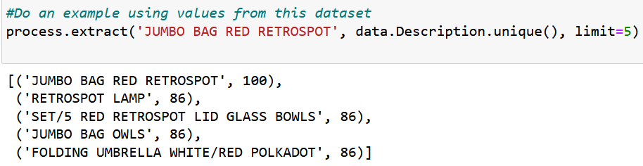
In the code above, the "extract" function within the "process" module is used to evaluate the similarity between the string "JUMBO BAG RED RETROSPOT" & every other of the 4,000 distinct product 'Description's in the dataset. Only the five strings with the highest similarity scores were returned. Obviously, this string has a score of 100 with itself, but the four following strings illustrate how these scores are calculated. Of the main string, which refers to a bag, only one of these latter four product 'Description's also refers to a bag, yet, it has the same similarity score with this main string as the other three products do. These distinctions are important to keep in mind regarding the effectiveness of this approach.
The approach going into this part of the project ideally would've evaluated each of the 4,035 distinct product 'Description's & calculated the similarity score between each pair of values; however, this would've amounted to a universally-large number of computations this is not possible nor realistic to accomplish given the hardware being used to perform this code. As such, only 500 unique product 'Description's were put through this arithmetic, which were randomly selected. Note that every time the python notebook is run, it will produce different product 'Description's, & so if the code is rerun at all, this should be kept in mind as it may not directly relate to what is discussed in the rest of this report.
The variable "df_random_descs_sim_scores," which contains the main data of interest, details similarity scores for 500 random 'Description' values as calculated using fuzzy string matching. For each of these 500 'Description's, this dataset contains the five most similar 'Description's & their similarity scores (SS). These scores are calculated based on the linguistic commonalities between each pair of strings; the higher the value, the more similar the two pieces of text. These similarity scores range from 0-100. An excerpt of this is shown below along with some statistical data regarding the similarity-score (SS) columns; "Desc" is short for "Description."
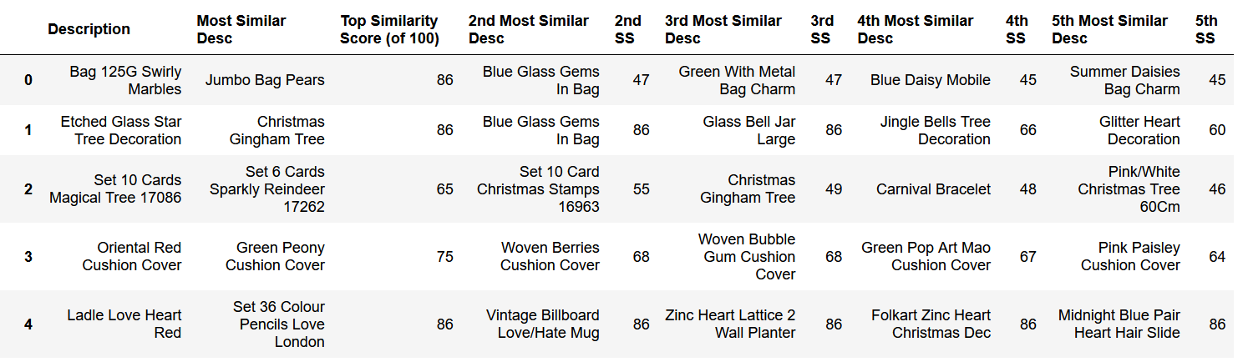
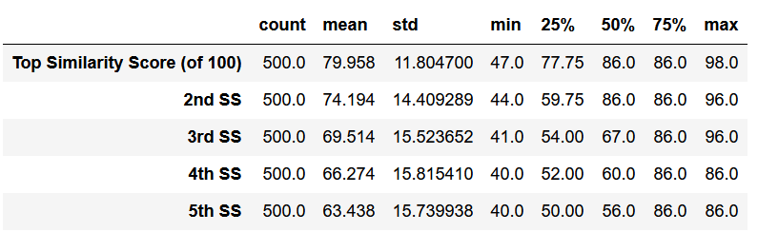
Given the aggregate statistics across the five columns containing the similarity scores, some investigating was done by checking some of the most & least similar 'Description's to better understand why their scores were so high & low respectively. As mentioned previously, a high similarity score doesn't necessarily imply that the two 'Description's revolve around the same product. Such cases could contain similar adjectives & other terms while still pertaining to different products. Such analysis could provide some guidance as to how this data could be used to categorize the subset of products in the dataset.
In analyzing the most similar 'Description's of the data in the variable "df_random_descs_sim_scores," it is evident that some pairs of 'Description's differ by very minimal inconsistencies. The four 'Description's with a 'Top Similarity Score' of 98 all seem to pertain to the same product, their only difference being in a couple of characters: "Acrylic Jewel Snowflakepink" & "Acrylic Jewel Snowflake, Pink"; "Acrylic Jewel Snowflake,Pink" & "Acrylic Jewel Snowflake Pink." Just with this information, it is probable that these pairs of values refer to the same product & only differ due to some typo, clerical mistake, or some other error. Nonetheless, it is possible that they refer to different products, or that these items have some small difference that is not quantified in this piece of text.
This can be verified by referencing the original dataset. For three of these four product 'Description's, they have the same 'StockCode' & that of the other only differs by one digit. Therefore, there is some reason to suggest that the difference in the 'Description' values have to do with a typo or some similar mistake. As such, these product pairs should be grouped into a category together.
Other than these four 'Description's, the next most similar pairs of products do have some clear difference between them which usually pertains to some descriptive identifier such as the color, size, or some other key feature regarding the products' design/appearance. Additionally, some other 'Description's & the value they relate the most to contain the same words, but they are either organized differently or there is one single character that differs between the two. The fact that so many distinct 'Description' values are formatted inconsistently &/or contain typos is concerning & inconvenient for performing data analysis (something to bring up to the manager). Moreover, it makes the actual total number of distinct products more difficult to assess. Nonetheless, for 'Description's with a similarity score of at least 87, these pairs of products describe the same general item.
As soon as the similarity score descends below 87 is when pairs of product 'Description's start to refer to different products. Many of these pairs seem to have such a large similarity score because they share some common word(s) (e.g. "Set," "In," some attribute referring to the color or size, etc.); however, there are some cases in which the pairs of 'Description's do refer to the same general item.
As such, pairs of 'Description's with similarity scores of at least 87 can easily be grouped into categories together. At a score of 86 & below, this is not the case & the categorization process would require much more tedious analysis because each pair of 'Description's would have to be looked at by hand to determine if they belong in the same category or not. Regarding pairs of 'Description's with a similarity score of 87 or more, they were classified into some hypothetical categories below as an example of how this process would work. To start, 33 distinct product 'Description's were classified across five categories. To help understand what some of these products actually were, they were looked up online. The products are listed as they appear in the 'Description' column in the dataset.
- Accessories:
  - Letter "C" Bling Key Ring, Letter "E" Bling Key Ring, Letter "G" Bling Key Ring, Letter "T" Bling Key Ring
- Decorative:
  - Number Tile Cottage Garden 7, Number Tile Cottage Garden 9
  - N0 Singing Metal Sign, No Singing Metal Sign
  - Flower Purple Clock W/Sucker, Flower Purple Clock With Sucker, Flower Blue Clock With Sucker
  - Cream Delphinium Artificial Flower, Blue Delphinium Artificial Flower
  - Hanging Chick Green Decoration, Hanging Chick Cream Decoration
  - Crystal Chandelier T-Light Holder, Ivory Chandelier T-Light Holder
  - Embroidered Ribbon Reel Rosie, Embroidered Ribbon Reel Ruby
- Holiday:
  - Acrylic Jewel Snowflake,Pink; Acrylic Jewel Snowflake Pink; Acrylic Jewel Snowflake, Pink; Acrylic Jewel Snowflakepink
  - Wrap Gingham Rose, Gingham Rose Wrap
- Kitchen:
  - Ceramic Cake Stand + Hanging Cakes, Ceramic Cake Bowl + Hanging Cakes
- Storage:
  - 50'S Christmas Gift Bag Large, "Gift Bag Large 50S Christmas", Gift Bag Large 50'S Christmas, "50S Christmas Gift Bag Large"
  - Blue Bunny Easter Egg Basket, Cream Bunny Easter Egg Basket
A previous example of the results of this code & their 'Description' values were classified into the categories listed below. It includes 32 distinct product 'Description's.
- Accessories:
  - Letter "G" Bling Key Ring, Letter "H" Bling Key Ring, Letter "V" Bling Key Ring
  - Hot Water Bottle Babushka Large, Hot Water Bottle Babushka
- Books:
  - Bundle Of 3 Alphabet Exercise Books, Bundle Of 3 Retro Exercise Books
- Decorative:
  - Zinc T-Light Holder Stars Large, Zinc T-Light Holder Star Large
  - French Blue Metal Door Sign 4, French Blue Metal Door Sign 6, French Blue Metal Door Sign 8
  - Home Garland Painted Zinc, Love Garland Painted Zinc
  - Blue Delphinium Artificial Flower, Cream Delphinium Artificial Flower
  - Hanging Metal Heart Lantern, Hanging Metal Star Lantern
- Holiday:
  - White Christmas Garland Stars Trees; Christmas Garland Starstrees; Christmas Garland Stars,Trees
- Kitchen:
  - Set Of 16 Vintage Rose Cutlery, Set Of 16 Vintage Red Cutlery, Set Of 16 Vintage Pistachio Cutlery
- Office Supplies:
  - Pink Diamante Pen In Gift Box, Silver Diamante Pen In Gift Box
- Storage:
  - Gymkhana Treasure Book Box, Gymkhanna Treasure Book Box
  - Large Deco Jewellery Stand, Large Jewellery Stand
- Toys:
  - Blue Shark Helicopter, Red Shark Helicopter
These eight hypothetical categories above may already be encroaching the limit regarding the number of categories requested by the manager considering how few products are included. As such, they may need to be reclassified into more generic categories. An example is listed below containing the same 32 'Description's across only five categories.
- Accessories:
  - Letter "G" Bling Key Ring, Letter "H" Bling Key Ring, Letter "V" Bling Key Ring
  - Hot Water Bottle Babushka Large, Hot Water Bottle Babushka
  - Pink Diamante Pen In Gift Box, Silver Diamante Pen In Gift Box
- Decorative:
  - Zinc T-Light Holder Stars Large, Zinc T-Light Holder Star Large
  - French Blue Metal Door Sign 4, French Blue Metal Door Sign 6, French Blue Metal Door Sign 8
  - Home Garland Painted Zinc, Love Garland Painted Zinc
  - Blue Delphinium Artificial Flower, Cream Delphinium Artificial Flower
  - Hanging Metal Heart Lantern, Hanging Metal Star Lantern
  - White Christmas Garland Stars Trees; Christmas Garland Starstrees; Christmas Garland Stars,Trees
- Home:
  - Bundle Of 3 Alphabet Exercise Books, Bundle Of 3 Retro Exercise Books
  - Set Of 16 Vintage Rose Cutlery, Set Of 16 Vintage Red Cutlery, Set Of 16 Vintage Pistachio Cutlery
- Storage:
  - Gymkhana Treasure Book Box, Gymkhanna Treasure Book Box
  - Large Deco Jewellery Stand, Large Jewellery Stand
- Toys:
  - Blue Shark Helicopter, Red Shark Helicopter
If all of the products across these examples were compiled into one list (62 distinct 'Description's), they could be categorized as follows.
- Accessories:
  - Letter "C" Bling Key Ring, Letter "E" Bling Key Ring, Letter "G" Bling Key Ring, Letter "H" Bling Key Ring, Letter "T" Bling Key Ring, Letter "V" Bling Key Ring
  - Hot Water Bottle Babushka Large, Hot Water Bottle Babushka
  - Pink Diamante Pen In Gift Box, Silver Diamante Pen In Gift Box
- Decorative:
  - Number Tile Cottage Garden 7, Number Tile Cottage Garden 9
  - N0 Singing Metal Sign, No Singing Metal Sign
  - French Blue Metal Door Sign 4, French Blue Metal Door Sign 6, French Blue Metal Door Sign 8
  - Flower Purple Clock W/Sucker, Flower Purple Clock With Sucker, Flower Blue Clock With Sucker
  - Cream Delphinium Artificial Flower, Blue Delphinium Artificial Flower
  - Hanging Chick Green Decoration, Hanging Chick Cream Decoration
  - Crystal Chandelier T-Light Holder, Ivory Chandelier T-Light Holder, Zinc T-Light Holder Stars Large, Zinc T-Light Holder Star Large
  - Embroidered Ribbon Reel Rosie, Embroidered Ribbon Reel Ruby
  - Home Garland Painted Zinc, Love Garland Painted Zinc
  - Hanging Metal Heart Lantern, Hanging Metal Star Lantern
- Holiday:
  - Acrylic Jewel Snowflake,Pink; Acrylic Jewel Snowflake Pink; Acrylic Jewel Snowflake, Pink; Acrylic Jewel Snowflakepink
  - Wrap Gingham Rose, Gingham Rose Wrap
  - White Christmas Garland Stars Trees; Christmas Garland Starstrees; Christmas Garland Stars,Trees
- Home:
  - Bundle Of 3 Alphabet Exercise Books, Bundle Of 3 Retro Exercise Books
- Kitchen:
  - Ceramic Cake Stand + Hanging Cakes, Ceramic Cake Bowl + Hanging Cakes
  - Set Of 16 Vintage Rose Cutlery, Set Of 16 Vintage Red Cutlery, Set Of 16 Vintage Pistachio Cutlery
- Storage:
  - 50'S Christmas Gift Bag Large, "Gift Bag Large 50S Christmas", Gift Bag Large 50'S Christmas, "50S Christmas Gift Bag Large"
  - Blue Bunny Easter Egg Basket, Cream Bunny Easter Egg Basket
  - Gymkhana Treasure Book Box, Gymkhanna Treasure Book Box
  - Large Deco Jewellery Stand, Large Jewellery Stand
- Toys:
  - Blue Shark Helicopter, Red Shark Helicopter

Provide ideas for further analysis
Obviously, the most effective way to expand further on the analyses discussed in this report would be to utilize some more powerful techniques, such as a natural language processing method or machine learning application. These methods would be much more capable of effectively categorizing the 4,000-plus unique product 'Description's.
Furthermore, when classifying products into categories, further analysis could break these categories down into subcategories. These could be based on multiple factors pertaining to the inherent nature of the products such as their size, color, price, & other physical & associated details.
Conclusions
Recall the goals of the project. The primary objectives included:
- Make note of strange values in the dataset that can influence the evaluation of the analysis. Clarify how to deal with these strange values.
- Determine a course of action (or multiple) to categorize the products in the dataset & evaluate their effectiveness.
- Perform analyses using various parameters in the dataset.
- Provide ideas for further analysis.
The analysis of the project associated with this report sought to analyze distinct products that are sold by this company & determine & evaluate approaches that could be used to categorize them. Given the size & inconsistencies in the values in this parameter that describes these products, it was difficult to determine realistic & efficient methods that could be used to sufficiently evaluate & classify the many products. With over 4,000 distinct products, the most ideal techniques would involve using some natural language processing application or machine learning program. Unfortunately, a lack of experience, knowledge, & confidence in this subject restricted the analyses of this project to more elementary methods including quantifying the products based on their values across the 'Quantity' & 'UnitPrice' columns, compiling a word count of words & phrases across the product descriptions, & string matching. The latter two approaches used the 'Description' parameter.
One important aspect regarding the 'Description' parameter, which described the associated product in a data point, was that not every value directly referred to a product. There were several instances in which the value of this parameter theoretically described some important notes regarding the nature of an invoice such as a mistake made in the transaction, a reason as to why the order was cancelled/returned, or some other detail. These data points weren't necessarily relevant for the purposes of this project, & so it was important to account for these values either by filtering them out or dropping them from any relevant analysis. For the most part, these data points were able to be found based on the format of the text in the 'Description' column—these "non-products" usually were formatted in all lowercase letters whereas actual products were mostly formatted in all uppercase letters. Product descriptions that contradicted these trends were able to be looked up & filtered out manually.
It is important to note that the manager requested that "the products to be grouped into a small number of categories." Though slightly vague, a "small number" was taken to mean somewhere between 15-30 categories. As such, this is another fundamental aspect to keep in mind when brainstorming these categories.
The first main process utilized in this analysis involved splitting the 'Quantity' & 'UnitPrice' parameters into quantiles. Based on the values of each distinct 'Description' across these two parameters, they were used to group different 'Description's into 20 different categories. This identified what products had the greatest & smallest size orders & what products were the cheapest & most expensive.
Next, the analysis revolved specifically around the 'Description' parameter. The first process involved compiling a word count of each distinct group of characters across each 'Description' value in the dataset. The goal of this method was to determine the most popular words that pertained to actual physical items in order to help provide some basis as to what the categories could potentially be & what items they could encompass. This process wasn't ideal for a couple of reasons. Firstly, it was not incredibly effective in using the most popular words to understand what kinds of actual items there were in the dataset. This limited the analysis' ability to conceptualize the most ideal categories that could encompass the few thousand unique products. Secondly, several words that were compiled were found across multiple product 'Description's, & so it wasn't directly clear as to what item each word could possibly refer to. Ultimately, to use this process to categorize the 4,000-plus unique products, it would require an extremely time consuming & tedious process where it is likely for some human error to occur such as some 'Description' being misidentified, or some value(s) being inconsistently classified.
The final major approach utilized & evaluated in this section had to do with the concept of string matching, which relates two strings based on their linguistic patterns. Specifically, fuzzy string matching, or approximate string matching, was used to quantify the similarity between two 'Description' values. This was done by utilizing a feature of the fuzzywuzzy package called "process.extract()" which calculates a similarity score between two strings of data. This score is some integer value between zero & 100.
In using this approach, a data frame was compiled in which 500 unique 'Description' values from the original dataset were taken (randomly), & the five most similar product 'Description's were obtained along with their similarity scores. Ultimately, this data could be used to determine what products are similar to each other, thus providing some guidance as to what potential categories could be made & how many. Of course, this method would still require considerable levels of meticulous, by-hand analysis in the process of categorizing the 4,000-plus products, but if a metric is available that helps in this process, it would definitely aid in how tedious & time consuming it may be.
Upon investigating the results of this process, it was important to evaluate why different 'Description's were so similar to others. In other words, was their high similarity score because the 'Description's pertained to the same or similar products, or did it have to do with the other words in their 'Description's which don't directly specify what the product actually is (e.g. color, size, or some other adjective). For the 500 data points sampled, it was determined that for pairs of 'Description's with a similarity score of 87 or higher, they referred to the same product, but there were only a handful of such instances. At a similarity score of 86 or less, pairs of products didn't necessarily pertain to the same item. As a result, there were only a few product 'Description's that were immediately able to be categorized. A couple of examples were made in which seven categories encompassed 62 unique product 'Description's.
Although this method was effective for these few products, it was not necessarily realistic for all products. For items which don't have large similarity scores with any other product 'Description,' it doesn't provide much guidance as to what category such products fit best in.
In summary, the methods that were utilized exemplify how uninspiringly effective they were in their ability to create categories for & classify the 4,000-odd products. In particular, the most effective method evaluated was the initial approach which classified the products based on their 'Quantity' & 'UnitPrice' values; however, it didn't involve any analysis & classification as to the nature of the item itself (this would've involved the 'Description' parameter). To completely accomplish this analysis using these methods, it would take an unrealistic amount of time & labor, which only increases the chances of human error, potentially illegitimizing the results of such analyses.
Additional Notes
In the python notebook, the relevant analysis is in the Analysis IV section which starts at about two-thirds of the way into the python notebook.
This link contains the source of the dataset. The python notebook is contained & accessible in the folder which also contains this Word document. The python notebook is an HTML file titled "Python Notebook – E-Commerce Data."

Citations
Daqing Chen, Sai Liang Sain, and Kun Guo, Data mining for the online retail industry: A case study of RFM model-based customer segmentation using data mining, Journal of Database Marketing and Customer Strategy Management, Vol. 19, No. 3, pp. 197-208, 2012 (Published online before print: 27 August 2012. doi: 10.1057/dbm.2012.17).
Dutta, N. (2024, October 7). Fuzzy String Matching – A Hands-on Guide. Analytics Vidhya. https://www.analyticsvidhya.com/blog/2021/07/fuzzy-string-matching-a-hands-on-guide/. Accessed October 15, 2024.
Fabiendaniel. (2019, March 21). Customer Segmentation. Kaggle. https://www.kaggle.com/code/fabiendaniel/customer-segmentation. Accessed October 15, 2024.

